# Video Game Sales Analysis Report

# Abstract:

In light of the home video game industry's quick development and rise to prominence as a leading segment of interactive entertainment in the house, we aim to identify the elements of the video game market that most influence sales. This subject is especially important since, as the video game industry has grown, leading publishers and creators have attempted both vertical integration and horizontal expansion in an attempt to firmly establish the business. This paper examines video game sales by platform in the global market from a period spanning 1988 through 2016. The facts and data are demonstrated by tables, graphs, pie charts, and other pictorial representations, which enhances the effective visual representation and decision-making capabilities for business strategy.

# Key Insights

## Top games:

Wii Sports takes first place in sales. Wii Sports is a sports video game developed and published by Nintendo for the Wii video game console.

Other games rank as follows:

2- Mario Kart Wii,

3- Wii Sports Resort,

4- New Super Mario Bros,

5- Wii Play,

6- New Super Mario Bros Wii,

and so on...

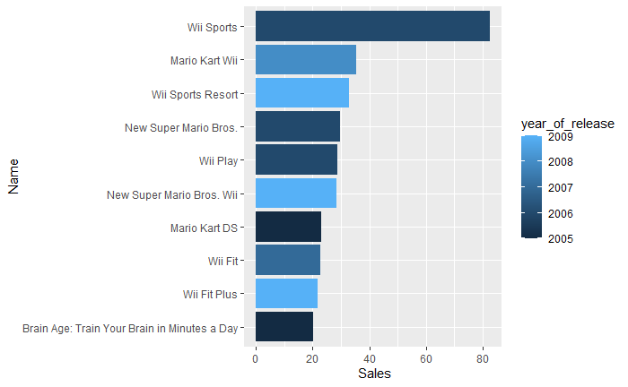

## Genre Analysis:

Action and Strategy games continue to dominate the market, reflecting the enduring appeal of high-energy, immersive gaming experiences. The two genres had the best count in the data as seen in the figure below

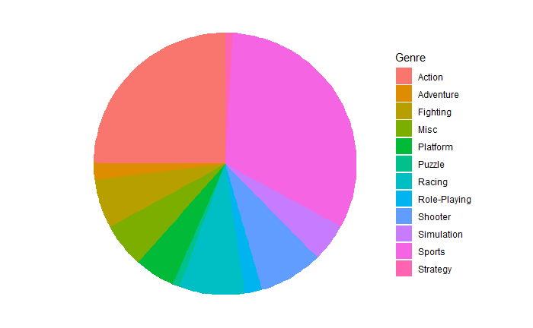

From checking the mean sales for each of the genres, Action, and sports had the high sales compared to other genres

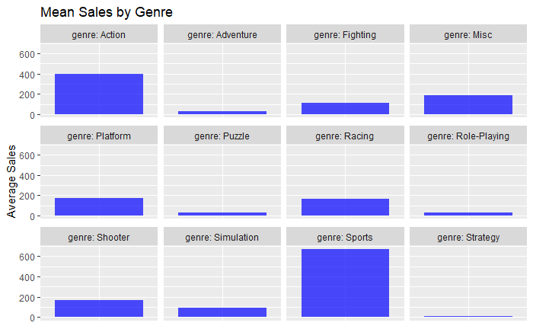

## Platform Analysis:

Consoles continue to dominate the market, but there is a rising trend in video gaming. The most popular platforms are PS2, X360, and PS3.

Platform-based markets induce new coordination behaviors between producers of games for the platform and the consumers of games on the platform, as moderated by the platform keeper. Additionally, the producers and consumers in this two-sided market are also subject to the coercive control exerted by the platform owner.

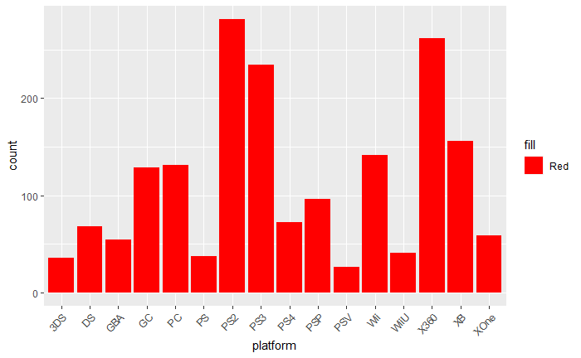

## Publisher Analysis:

Games published by Electronic Arts have major popularity in the market.

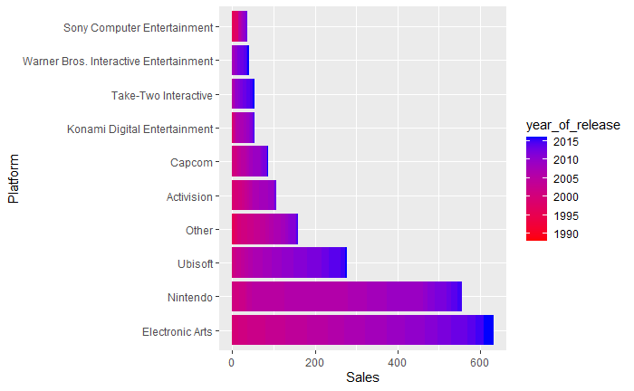

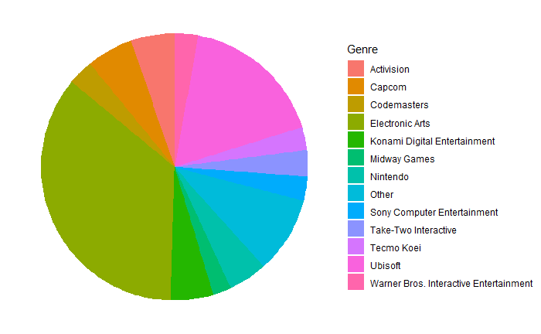

## Year of release analysis:

A crucial component of comprehending the evolution of the gaming industry and consumer trends is analyzing game sales according to the year of release. This analysis offers a thorough view of the gaming industry's development and resilience across time, facilitating a deeper understanding of the effects of historical events and technical breakthroughs on the market.

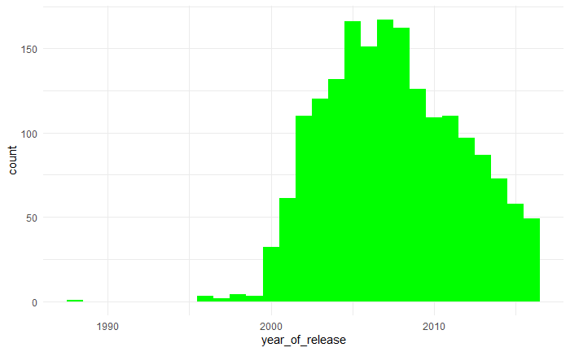

From the data, we can see that the most popular games were published between the year 2008 and 2010. Similarly, the sales of the games favored the games published within the same range of time as shown below.

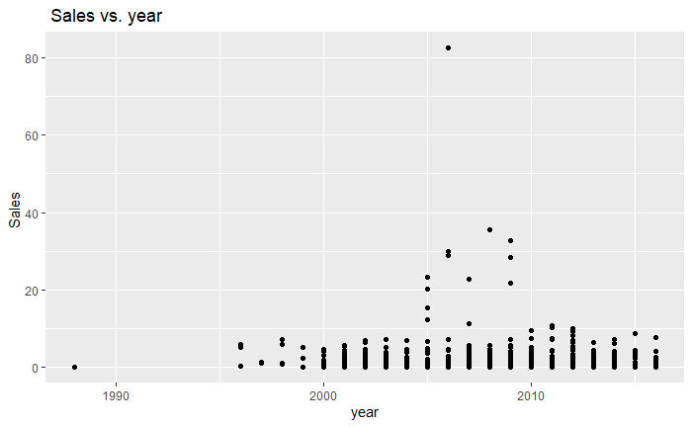

# Conclusion

Finding the enduring factors that have influenced the gaming industry's success throughout time is interesting because trends in this dynamic field come and go.

Some notable highlights have been identified by our analysis.

* Action games have been the most popular genre for a long time, winning over players of all ages with their charms and money.
* Numerous gamers have found an intense experience with the PlayStation 2, a classic gaming console that has maintained its position as the most popular gaming platform.
* Furthermore, 2008 is remembered as a turning point in the history of the video game industry.

These persistent patterns show that even if the game business is still changing. These Insights serve as a helpful reminder of the lasting popularity and strength of the gaming industry as we excitedly look forward to what the future holds.